**PLACEMENT MANAGEMENT PROJECT**

**Abstract:**

From a student’s perspective, placements can bring a wide range of benefits and opportunities. Training and management of placement is a crucial part of an educational institution in which most of the work is done manually. Manual system in the colleges requires a lot of manpower and time. With this project we aim to develop a web portal to solve this issue. The project is aimed at developing an application for the placement department of the college. The system is an application which will be accessed and effectively used throughout the organization with proper login enabled. It can also be used as an application for the Placement Officers in the college to manage the student information about placement thus reducing the manual work and consumes less paperwork. The system also provides the facility of viewing the personal and academic information of the student. The system gets the requested list of candidates for the companies who would like to recruit the people according to their eligibility criteria.

1. **INTRODUCTION**

Manual Training and Placement which is done at various colleges is by human intervention due to which there is a maximum chance of errors. The major problem is searching and updating of the student data. Placement officers have to manage the student’s profile and their documents. Placement Officer has to collect the information of various companies who comes for recruitment. They have to arrange profiles of students according to various streams and notify them each time according to company requirements. Placement officers submit the information of students and if any changes or updates are required in the profile of any student, it has to be done manually. This process is so difficult and tedious when the number of users increases. This is tedious and time consuming. Chances of missing data are also possible. It is also difficult for collecting, managing, and updating student data as the number of students increases. ’Placement Management System’ like many other placement management web sites, provides information on placement providers and the placements and also keeps up to date information of all students. It is a platform where students can view and assess their opportunities. The system will be having different types of accounts for different types of users such as Admin, Student, HODs, and tutor. A profile for each student is created with the necessary credentials for the portal. The system uses MySQL for database management and will sort the data of the student based on eligibility criteria demanded by the respective companies and a list of eligible candidates will be prepared and they can choose if they are interested to attend that particular drive or test. Based on this a final data-set is created and the interested candidates will be registered automatically by the system. This way it reduces the work of college staff or faculty from the problems caused by human error and wastage of time doing all processes manually.

**II. EXISTING SYSTEM**

Problems in existing system

• Maximum manual work: in the existing system all the work that is done by human intervention. Humans should do all the work.

• Errors: due to the manual intervention there are maximum chances of errors.

• Maximum human interface: the interface between the student and administrator is maximum.

• Time consuming: due to above problems every procedure becomes time consuming.

• File system: the records were stored in modified access sheets hence sorting problem.

• No hierarchical: the files were not stored hierarchical format hence searching problems.

• Updating records: due to above problems the updating was very difficult and ambiguous.

**III. PROPOSED SYSTEM**

The proposed Online Training and Placement System management system meant to give more easiness to the users that they can add and retrieve information so quickly.

There are mainly three types of users they are administrator, student and HR. The administrator is the master user; he gets the most number of priorities than the other users. The different functions involve the case of an administrator are updating, approval, sending information to the students regarding placements. The administrator can view and approve the various application forms. Students can register and view the details. The placement officer can login through HR section view the details of the HR’s, placed students, and training details.

The proposed online training and placement management system is intended to avoid all the drawbacks of existing system. It will add some more features than the existing system. The proposed system is a cost effective way of doing the manual processes done in the existing system.

The proposed system is intended to do the following:

• Security For Administrator: The files in which the data is stored is stored in Access file sheets that too separately for each class of department; so the files could be accessed by any one accessing the computer. These files may be ‘confidential’. So there is a special need for security.

• Optimized Sorting of data: The modified access sheets were not that efficient as, when we want to select students having 65% aggregate then the student with 70%, 75% aggregate were also selected where as required result is only students with 65% aggregate.

**FEASIBILITY STUDY:**

The purpose of the feasibility study is not to solve the problem, but to determine the problem is worth solving. This helps to decide whether to proceed with the problem or not. It involves the analysis of the problem & collection of all relevant information relating to the product such as items that would be input to the system, processing required to carried those data, the output data required to be produced by the system as well the various constraints on the behavior of the system. The feasibility study concentrates on the following, such as Technical Feasibility, Economic Feasibility,Operational Feasibility.

1. **TECHNICAL FEASIBILITY:**

It is technically feasible to design the project as; the entire modules described in the modules description can be created using Front-End interaction HTML and back end database mysql.

1. **ECONOMIC FEASIBILITY**

The economic feasibility study evaluate the cost software development against the ultimate income or benefits get from the developed system. There must be scope for profit after the success completion of the project.

1. **OPERATIONAL FEASIBILITY**

Operational feasibility study tests the operational scope of the software to be developed. The proposed software must have high operational feasibility. The usability will be high. REQUIREMENTS ANALYSIS: Requirements analysis is the process of defining what the user requires from the system and defining the requirements clearly and in an unambiguous state. The outcome of the requirement analysis is the software developing activities. Thus it deals with understanding the problem goals and constraints. This specification part mainly focuses on what had been found during analysis. A requirement is a relatively short and concise piece of information, expressed as a fact. It can be written as a sentence or can be expressed using some kind of diagram .requirements are divided into two major types functional and nonfunctional. Functional requirements: Following is a list of functionalities of the system. More functionality that you find appropriate can be added to this list. And, in places where the description of functionality is not adequate, you can make appropriate assumptions and proceed.

**Inputs:** The Administrator handles the entire system. The role of administrator in the system is to upload the information like students information, job information, company information etc., Login to the system through the first page of the application Changing the password after logging into the system if required.

**Requirement Specification:** Complete specification of the system (with appropriate assumptions) constitutes this milestone. A document detailing the same should be written and a presentation on that be made.

**Database Creation:** A database should be created, as per the rules for the purpose of maintenance of the records.

**Implementation Of The Front-End:** Implementation of the main screen giving the login, screen that follows the login giving various options, screens for each of the options are provided **Integrating The Front-End With The Database:**

The front-end developed in the earlier milestone will now be able to update the database. Other features like mail notification etc should be functional at this stage. In short, the system should be ready for integration testing.

**Processing**: As the system is information-oriented project and there are no certain calculations only database storage and view is provided.

**STORAGE DATA:** In this we store all the details of students, company information and recruiter information.

**Outputs:** The project provides information required by organization.

**Non-Functional Requirements:** Non-functional requirements are the constraints that must be adhered during development. They limit what resources can be used and set bounds on aspects of the software’s quality.

**User Interfaces:** The User Interface is a GUI developed using HTML Software Interfaces: The main processing is done on the server side using apache tomcat and for the programming environment java is used, for backend database mysql is used.

**Performance Requirements:** The product performance needs to be assessed on certain characteristics. Input: The inputs that the student gives i.e., user id and password is very important.

Technology is Used:

Front end: HTML, CSS, JavaScript

1. HTML: HTML is used to create and save web document. E.g. Notepad/Notepad++
2. CSS : (Cascading Style Sheets) Create attractive Layout
3. Bootstrap : responsive design mobile friendly site
4. JavaScript: it is a programming language, commonly use with web browsers.

Back end: JAVA, MySQL

1. CORE JAVA:
2. MySQL: MySql is a database, widely used for accessing querying, updating, and managing data in databases.

The database definition or descriptive information is also stored in the database in the form of dictionary; it is called Meta data.′ Defining a database involves the specifying the data types, structures, and constraints of the data to be stored in the database. ′ DBMS is a general –purpose software system that facilitates the process of defining, constructing, manipulating, and sharing database among various users and applications. ′ Database Management System (DBMS) is a collection of programs that enables users to create and maintain a database.

TABLES USED IN THIS PROJECT

1. Admin Login Details

2. Faculty Details

3. Student Details

4. Subjects

5. Courses

6. Departments

7. Batches

8. Semester

9. Placement Office

**′DATABASE DESIGN PROCESS**

1. HOME PAGE
2. LOGIN PAGE
3. NEW STUDENT REGISTRATION PAGE(ADMIN)
4. NEW FACULTY REGISTRATION PAGE
5. ADD STUDENT ACADEMICS (UPDATING STUDENT SEMISTER GRADES BY ADMIN)
6. SEARCH ACCORDING TO BATCHES BY FACULTY (FACULTY SELECTS THE BATCH HE WANTED TO VIEW)
7. RESULT OF BEFORE PAGE
8. FILTER STUDENTS ACCORDING TO THEIR CGPA BY TPO ADMIN
9. RESULT OF BEFORE PAGE (STUDENT LIST WITH CGPA ABOVE 6.5)

**Placement management System there are following module and their design details are as follows.**

**Student Module:**

In the student module first the student should get registered to the system by filling the placement registration form which contains the details such as name, USN, course, email, mobile number and password. Once the student fills the placement registration form the account activation link will be sent to the students email to activate their account .Once the student activates the account they can login to the system through the username and password and should fill the academic registration form. The application form will contain the details such as personal details and educational qualifications. After filling the application form the student should download the application form and should submit in the placement cell. Once the student completes filling the registration form and submits the application form to the placement officer the student will not able to login to the system this is the key feature of this project. The placement officer will check the details of the student and verify it. After verifying the student if his details are correct the placement officer will inactive the student if the placement officer in actives the student then the students will not be able to login to their account. This is done because more often the student can login to the system and can change his details. So in order to avoid this, the option of inactive the student is provided. If the student wants to change/update his details then the student should meet the placement officer to do the necessary changes.

**UseCase Diagram:**

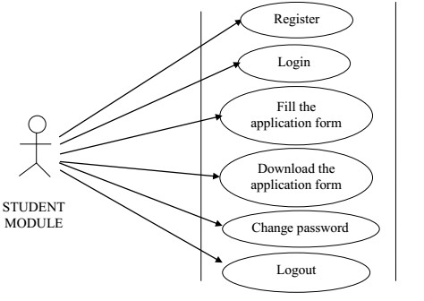

Fig. 1. Use Case Diagram For Student Module

**Admin Module:**

The training and the placement officer is the administrator in the system. The administrator plays an important role in the project. In this module admin will login through username and password, once he logins he will be directed to the dashboard where he gets the complete details of every student of different courses and departments. The admin can add the newly added courses, departments and also can add new batch. The admin can also view the complete list of courses, departments, and batches. The admin can filter the students according to his needs through the search option, for example if the admin requires the student whose aggregate is greater than 65% in BE and greater than 70%in PUC and 10th.The admin is provided the option of search in which he can search the students using the name, mobile num, USN, Email ,and registration ID. The admin is also provided with an option of sending bulk SMS and Emails. Administrator can send the bulk SMS and Emails to the students by filtering the students as he needs. Once the students submit the application form in the placement cell the placement officer can verify the details put up by the students. A unique registration ID will be generated for every student using this ID the placement officer can verify the students. The administrator also has the option of sending the templates to the students, it’s like if the student is eligible to the drive a template is sent to the students email with a unique registration ID, the students should take the print out of that template and should attend the placements.

**UseCase Diagram:**



Fig 2. Use Case Diagram For Admin Module

**HR Module:**

The training and placement officer can also login to the HR section through the username and password. In this HR section all the information related to the HR’S are maintained. The placement officer can add the newly visiting company name to the database. The TPO can assign the company, assigning the company is nothing but in which year it is visiting, what’s the company criterion etc. The TPO should map the students, mapping the students is nothing but if the students get placed in some company the TPO should update the details such as in which company the student has been placed. The TPO can maintain all the HR’S information in this section by adding the details of the HR such as his name, mobile number, HR level, email, company name etc. The TPO can also maintain the information of other college TPO details. In this section the TPO have the option of maintaining the workshop or training details that are going to be held in the college. The admin can download all the details of the HR’s, placed students, training details, and all assigned companies in to the excel sheet.



Fig. 3. Use Case Diagram For HR Module

USE CASE DIAGRAM:

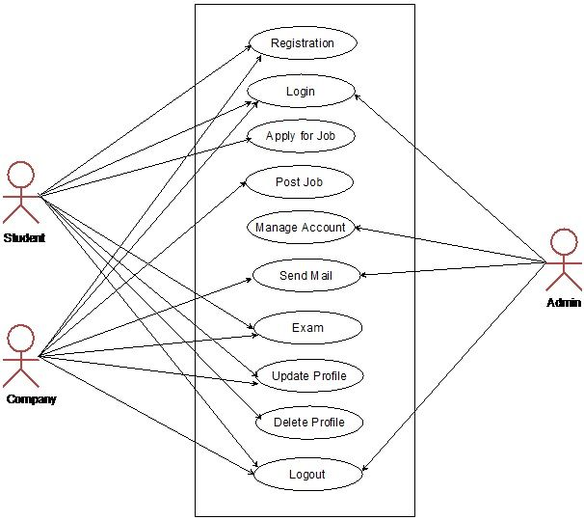

Fig. UseCase Diagram

**E-R Diagram:**

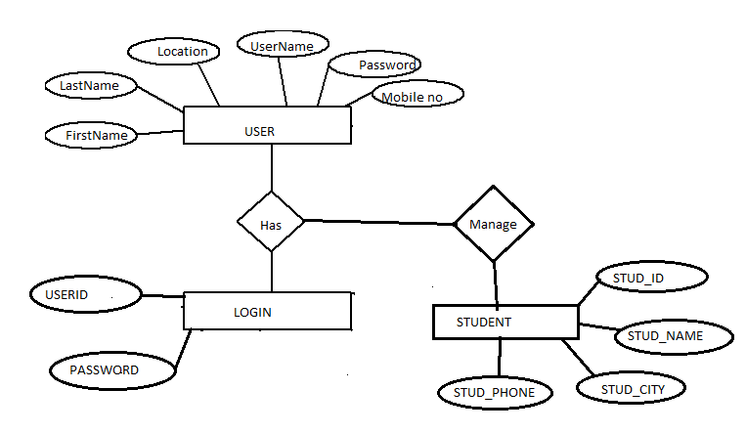

**Class Diagram:**

Class diagrams are arguably the most used UML diagram type. It is the main building block of any object

oriented solution. It shows the classes in a system, attributes and operations of each class and the relationship between each class.



**Fig 4. Class Diagram For Online Training And Placement Management System.**

1. **CONCLUSION:** The introduction, problem definition of the project has been completed successfully to college Web based placement management system by maintaining the student details related to placement in an efficient manner. Malpractice can be reduced.′ It provides accurate information always. ′ It reduces the man power required. ′ It can be monitored and controlled remotely. ′ This is a paperless work. ′This project assists in automating the existing manual system.

**REFERENCES:**

1. Roger S Pressman, “Software Engineering – A Practitioner’s approach” McGraw – Hill International Editions, Fifth Edition, 2001.

2. Henry F Korth, S. Sudharshan, “Database System Concepts” McGraw – Hill International Editions, Fourth Edition, 2002.

3. George Koch, Kevin Loney, “Oracle – The Complete Reference”, Tata McGraw Hill, Third Edition, 2001.

4. Herbert Schildt& Patrick Naughton, “Java2 Complete Reference”, Tmh 3/e, 1999.

5. James Jawroski, “Mastering Java Script”, Tmh 3/e, 2000.

6. D.J. Abadi, “Data Management : Limitations and Opportunities,” IEEE Data Eng. Bull., vol. 32, no. 1, pp. 3-12, Mar. 2009. 7. “Microsoft SQL Server”,Solomon ,Rankins-SamsPublications,Second Edition